**GPU shaders for advanced visualisation**

**Colbere Patricia**

Shaders in computational engineering have been invented to make graphics rendering easier and more efficient. They are also flexible and can transform vertices and pixels to apply special effects on an image. They can be used for a variety of applications, like filters or changes on an image or a video, the rendering of fluids, a good flexibility for each type of rendering required, or it can be used for virtual reality in the context of architectural design and modelisation.

Shaders can be used to make changes on a static image or on a dynamic video. If we want to make 3D graphics, using shaders is a good solution to have good and fast results. Indeed, shaders can transform a lot of elements at once on different pixels or vertices. This is useful for games, where the shader can change a whole screen, or it can change only some of the shown objects. There are also ways to generate textures with a shader for some objects so that they are calculated and rendered to the screen, for example to represent some parquet on the ground. Additionally, a lot of useful effects can be added, like colour filters or gradients. Besides these static effects, dynamic effects can also be generated. Combined with a timer that can give us periodic effects, like a moving lighting effect.

Because shaders use the GPU, they can be used for parallel programming, which makes the rendering even more efficient. This can be useful in complex renderings, such as fluid dynamics simulations. Fluids are very present in our world, so it is obvious that it can be useful to simulate. However, fluids are very complicated to simulate as they require a lot of calculations even when we try to simplify it, because we want to have a model for as many particles of fluid as possible. These fluids can also interact not only with the other particles of the same fluid, but also with other objects, solids or other fluids. The simulations of fluids can be made in 2D or 3D with a shader, however it will be more costly to generate the simulation in 3D, so it is better to do it in parallel programming to have a good speedup and efficiency. These fluid simulations can then be integrated in more complex graphics applications.

Adding shaders to a software makes it more flexible and easier to maintain. Using a shader prevents us from adding custom code directly inside of our software, and it lets us easily design and implement new effects. With individual programs, we can implement a vertex shader or a pixel shader for a type of rendering. However if we use a big number of effects, it becomes complex to manage. That is why we can instead use effect files to have all the programs for a rendering style in one shader resource. This makes it easier to access and to use. This way every rendering style can be used easily anywhere we want.

Shaders can also be used for virtual reality, like for the architectural designers. Indeed, real-time shaders can then be used to visualise 3D models in virtual reality. Before virtual reality advanced shaders were mostly used for 3D gaming for real-time 3D graphics generation. Advanced shaders, unlike traditional shaders, can render complex 3D effects dynamically, such as light refraction and reflection or moving water. Thanks to this, very realistic images can be produced. However advanced shaders still have to be adapted by a programmer to the software they are used by. If we use advanced shaders for architechtural virtual reality dynamically, we can improve the realism of our models compared with the traditional shaders. Therefore the designs modelled will be better represented and the viewer will better experience a result near what should be once it is actually made. Indeed water represented with an advanced shader can be shown moving with a certain speed, a wave length and height. It will be represented realistically from all angles observed. That is why advanced shaders can be very useful for virtual reality applied to architechture.

Therefore, shaders are nowadays crucial and are more and more used. That is because they can be used to apply a filter, static or dynamic, or to render a fluid. They are efficient and flexible, despite having to be adapted to the software they are used in. Their efficiency can also be improved by using parallel programming to render in 3D quickly. Finally, they can also be used to render architechtural designs with virtual reality. As shaders have been used in an increasing manner, their applications are numerous and new ones will also be found in the coming years as shaders keep developing and becoming more accessible to render more and more realistic models.

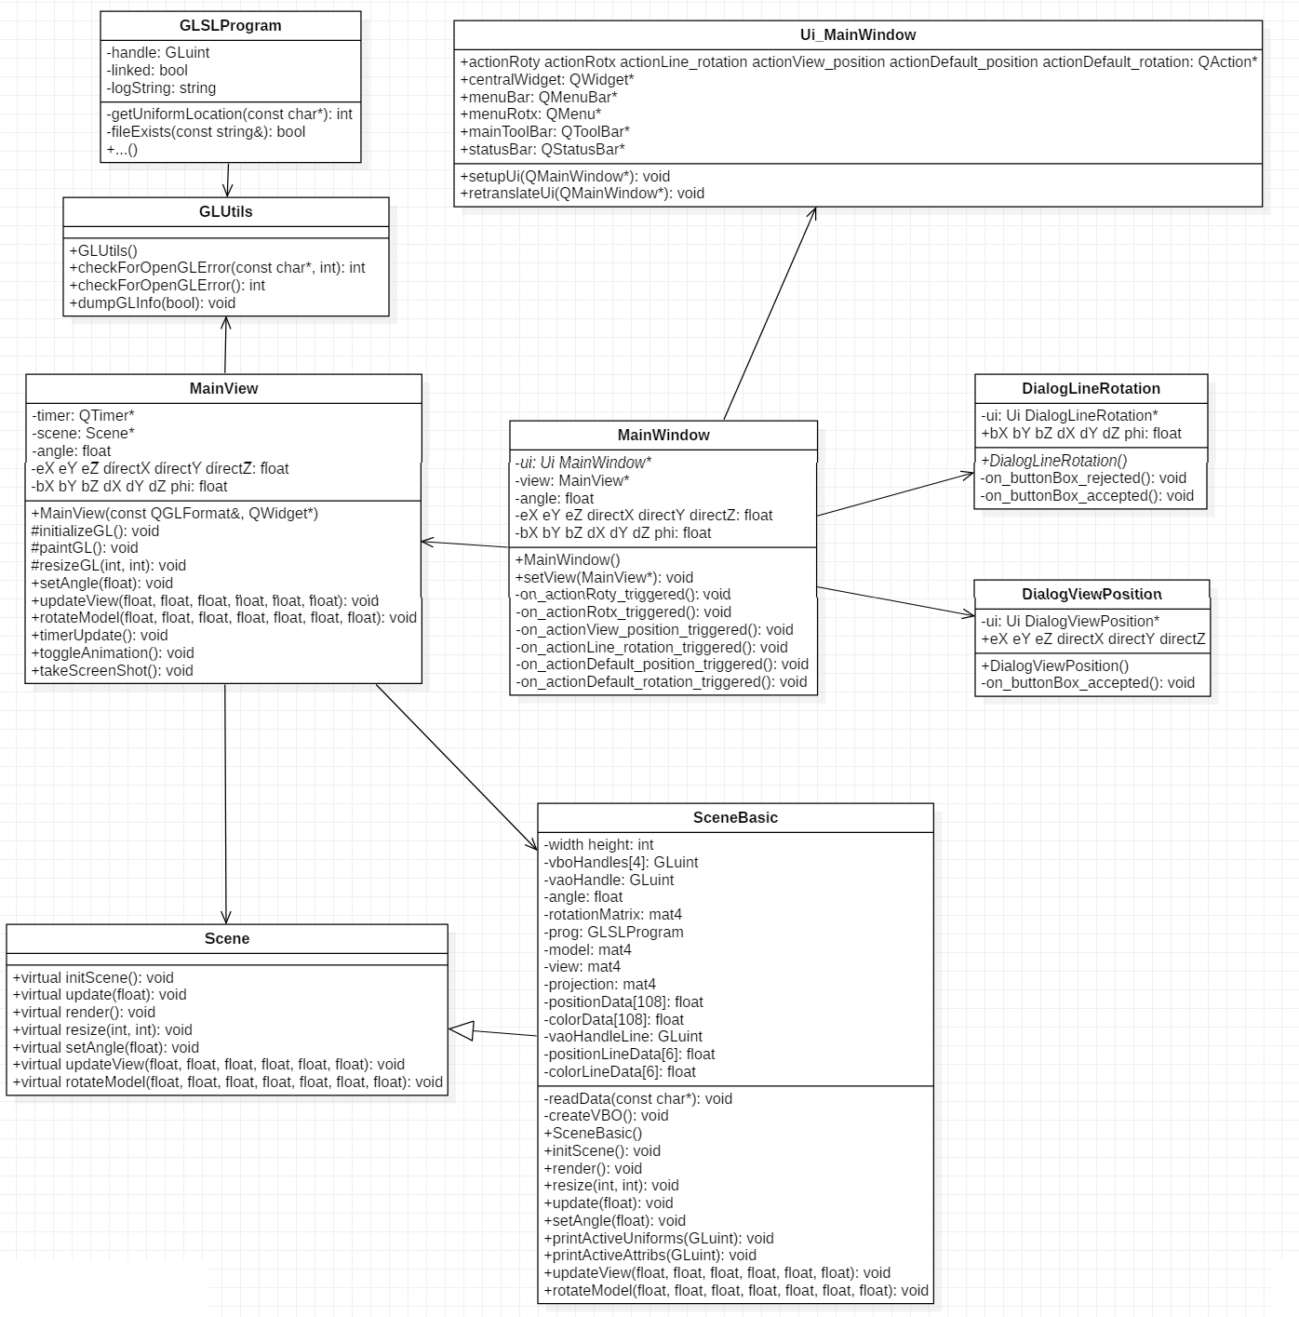UML Class diagram of the project